**Introduction**, **Three Components of SCM**, **Demand Management**, **Demand Forecasting**; **Introduction**, **Supply Management**, Evolution of ERP, **Concept of ERP in SCM**, Quick Response and Accurate Response System in SCM, Use of Other Planning Strategies

**Components of SCM**

**Planning , sourcing, inventory, production or transport, return of goods (Mentioned in Unit-I)**

**Demand Management**

Focused effort to estimate and manage customer’s demand

Demand management is a **planning methodology**. Companies use it to **forecast** and plan how to **meet demand** for services and products. Demand management improves connections between **operations** and **marketing**.

The process of **understanding**, **forecasting**, and **managing customer demand** for products or services is known as demand management. It is practiced by businesses to forecast demand accurately and involves **analyzing historical data, market trends, and customer behavior.** Demand management makes it possible for businesses to optimize their supply chain operations, production schedules, and inventory levels.

 By ensuring that products are available when and where customers need them, demand management helps them **minimize stock-outs, eliminate excess inventory, and improve customer satisfaction**. Businesses can lower expenses, boost income, and enhance overall operational effectiveness by optimizing their demand management processes.

[**Demand management**](https://www.pickrr.com/blogs/on-demand-deliveries-in-b2b/) is critical in any business because it helps to ensure that the right products or services are available at the right time and in the correct quantity.

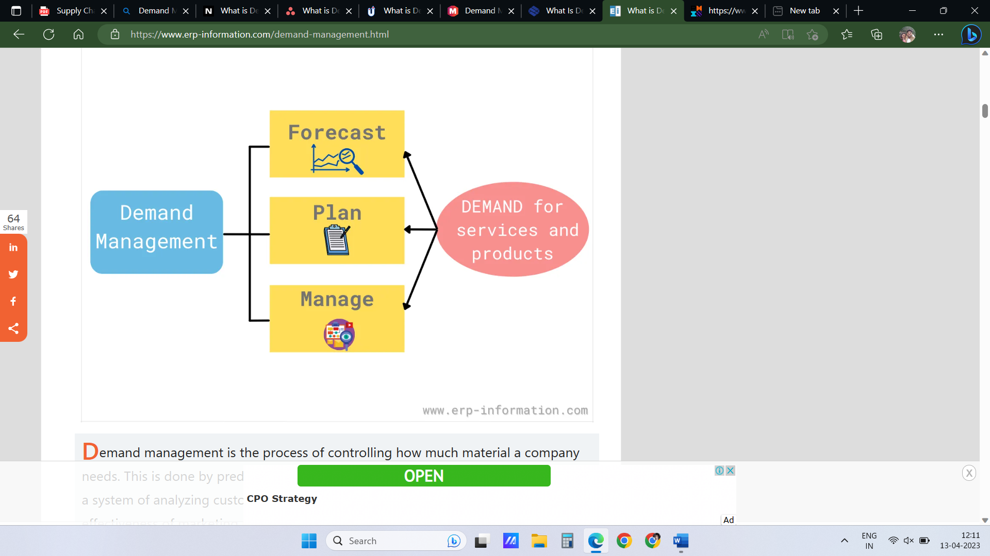

**What Are the Functions of Demand Management? Eg- TV**

There are five primary functions of demand management, which are:

### ****Data Collection****

The demand management process begins with collecting data on **sales history**, **market trends**, and **customer behavior**. This data is essential for accurate demand forecasting. Data collection involves using various tools such as surveys, customer feedback, and market research to gather customer demand and behavior data.

**Forecasting Demand**

Demand management’s primary function is accurately forecasting demand for products and services. This involves analyzing historical sales data, market trends, and [**customer behavior**](https://www.pickrr.com/blogs/how-to-personalize-your-ecommerce-customer-experience/) to predict future demand. Forecasting demand is critical for businesses to plan inventory levels, production schedules, and pricing strategies. Accurate demand forecasting helps businesses optimize operations, reduce waste, and improve customer satisfaction.

**Setting Inventory Levels**

Based on the demand forecast, demand management helps businesses set appropriate inventory levels to ensure they have enough stock to meet customer demand without oversupplying and causing waste. [**Setting inventory**](https://www.pickrr.com/blogs/inventory-management-system/) levels is a delicate balance between meeting customer demand and minimizing waste. With demand management, businesses can optimize their inventory levels, reduce the cost of carrying excess inventory, and improve their bottom line.

**Production Scheduling**

Once demand is forecasted and [**inventory levels**](https://www.pickrr.com/blogs/inventory-management/) are set, demand management helps **schedule production** to meet customer demand efficiently. Production scheduling is critical for manufacturers who need to balance customer demand with production capacity and raw materials. With demand management, businesses can schedule production effectively, reduce lead times, and improve[**customer satisfaction**](https://www.pickrr.com/blogs/same-day-shipping/).

**Pricing Strategies**

Demand management also helps in setting pricing strategies that balance customer demand with profitability. It ensures businesses can price their products and services competitively while maintaining profitability. With demand management, businesses can optimize pricing strategies, improve revenue, and stay competitive.

**Objectives of Demand Management**

### 1. Enhance customer service

Enhancing customer experience was and will always be the primary objective of demand management as it focuses on ensuring that the products are available on when and where customers need them. Businesses can prevent stock-outs, shorten lead times, and increase order fulfillment rates by precisely anticipating demand and streamlining supply chain operations. This in turn contributes to greater client loyalty and satisfaction.

### 2. Better forecasting

**Increasing the accuracy of demand forecasts** is another objective of demand management. Organizations can find patterns and insights that help them estimate future demand more precisely by examining **historical data**, **market trends**, and **customer behavior**. As a result, they are able to more effectively plan and manage their production schedules, inventory levels, and supply chain operations.

### 3. Lower business costs

Lowering costs is a significant objective for most businesses, and demand management can help achieve this by decreasing **excess inventory and avoiding stock-outs**. By managing inventory levels and supply chain operations, firms can reduce holding costs, transportation expenses, and obsolescence costs. As a result, they are able to increase their profitability and competitiveness.

### 4. Product betterment

By precisely forecasting demand, businesses can find opportunities to enhance current products or release new ones that more effectively meet client needs. Organizations can also launch new products to market more swiftly and effectively by streamlining their supply chain operations.

**Demand and capacity management**

Focused effort to estimate and manage customer demand.

**Demand management identifies potential demand variations**.

Capacity management is a response to demand.

Capacity management aims to ensure **resources are available**, so **business activities** and **production** can thrive under any circumstances.

Originally two strategies were suggested for managing demand and capacity: the first would involve adjusting capacity to match demand (defined as ‘**chasing demand’**) and the second, altering demand to match available capacity (known as ‘level capacity’).

**1. Adjusting capacity to match demand**

**(i) Extend the opening hours** – This is not an option open to all service organizations. Where it is possible it is likely to occur only when demand levels are regarded as particularly **excessive**.

**(ii) Encourage employees to work harder** – The requirement here is usually that of processing more customers per hour or per day. Although a mark of efficiency (more output from existing staff), service quality for customers may deteriorate.

(iii) **Recruiting part-time employees** – This is an option low in cost and potentially one that can be achieved quickly. Organizations should, of course, ensure that part-time employees be given the same support and encouragement as given to full-time staff

(iv) **Add facilities** – Usually in the form of tables, chairs or other equipment. Just how much scope there is for this will depend on the initial configuration and layout designed to communicate a specific atmosphere and/or level of service. Adding facilities may change both.

(v) **Hire or share facilities or** **equipment** – May be in the form of **additional physical space** or **vehicles** required either on a temporary or recurring basis. Using customers as productive resources – up to this point all attempts at adjusting capacity have involved manipulating internal resources and assets. However some have suggested that organizations should regard customers as ‘partial employees’ and make a contribution to productive capacity.

(vi) **Outsourcing** – For small to medium-sized organizations, in particular, calling on outside assistance is a valuable option in trying to meet market demand. Typical areas for outsourcing are **technological** and **marketing support**, **employee recruitment** and **training**, and **Web development**. Large organizations also outsource. Consider the recent case of British Airways and the outsourcing of its inflight catering to Gate Gourmet. Competitive pressures in the airline industry had forced this move. Unfortunately, the demand for lower costs led to industrial action by Gate Gourmet employees. The above options, then, are aimed at increasing capacity to absorb demand.

**2. Altering demand to match available capacity**

Whereas capacity management is a response to demand, demand management is an attempt to shift demand. Given the relative inflexibility of capacity organizations may seek to smooth demand by reducing the variability and fluctuation of existing patterns. **Organizations can turn to the marketing mix for stimulating demand during periods of spare capacity or shifting demand during periods where capacity is operating at or near maximum**. Of the ‘4 Ps’ price and, to a lesser extent, place, offer the most potential in this area.

(i) **Manipulate price** – The central role of price is to discourage too many customers from using the service during ‘**peak demand’** periods and encourage more customers to select ‘**off-peak’** periods. On price alone this strategy will only work if enough customers can be attracted by the **lower prices** available during **low demand periods**. Leisure, **hospitality** and **transportation services** would appear suited to this approach. However this strategy of price differentiation is, it is argued, not without risk. Equally there is **risk to the organization’s image** in that **lower prices may attract undesirable customers**. This would be particularly relevant for a service that regards itself as more upmarket or exclusive.

(ii) **Offer a mobile service** – For a number of reasons consumers have welcomed the emergence of mobile services where the provider takes the service to the customer rather than or in addition to the customer having to visit the provider in some fixed location. Libraries have used this approach for many years, the service being particularly valued by the disabled and those living in remote locations. Other services that have found mobility an effective method of managing demand include breakdown and **maintenance, blood donation and catering.**

(iii) **Communicating with customers** – The provision of information as to when demand is, or is likely to be, high appears to be a strategy not well adopted by service organizations. In particular for customers in our ‘**call center society’** it can be especially frustrating. Waiting is a feature of modern day society and will be addressed later in the chapter. **Eg- credit cards, Personal Loan**

**(iv) Changing the service offer** – For most organizations this is not an option. What they offer remains fixed. Where services with a sizable facility like hotels experience significant seasonal fluctuations however, action may be taken to encourage varied usage of the facility when capacity is under-utilized.

**The Demand Management Process and concept**

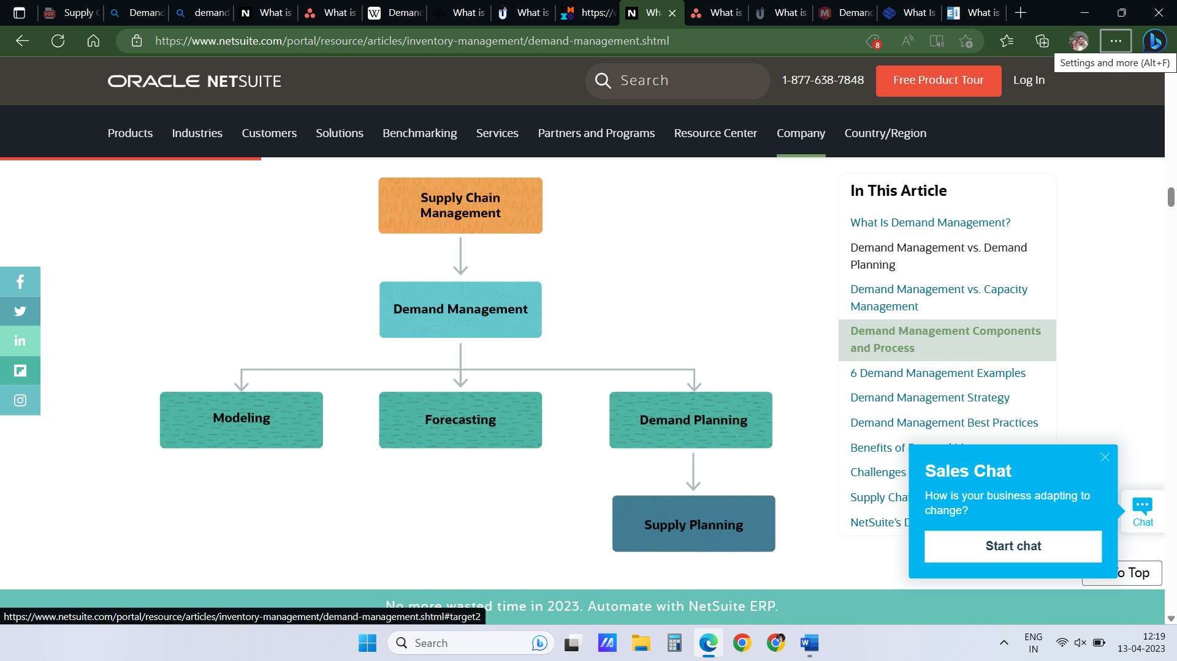

### Components of demand management

Each demand management process features components to identify and focus on customer needs. Based on the data derived from each element, managers arrive at the best plan to improve overall business performance and optimize the supply chain from end-to-end.

#### Step-1 **Modeling**

It is the process of **representing reality in a simplified way** that allows us to understand and predict behavior. In other words, it is a **means of understanding the past to anticipate the future better.**

A key step in the demand management process is modeling. The demand planning team gathers information from a variety of sources, including **sales and demand drivers**, **social** **media strategy**, and **market trends**. Once the information has been gathered, it is either manually examined for a variety of exercises, or it is manually entered into demand management and planning software.

### Step-2: Forecasting

Allowing companies to project future demand for their goods or services, forecasting is an essential step in the demand management process. By employing **predictive analytics**, businesses can yield accurate sales and revenue estimates that support trustworthy supply chain decisions.

Here are some key areas of focus for [demand forecasting](https://www.upperinc.com/guides/demand-forecasting/):

* **Objective setting:** Before starting the forecasting process, setting up specific goals that meet the demands of different departments, such as **product marketing**, **financial planning**, **operations**, and **logistics**, is essential.
* **Collection and data recording:** Businesses must combine data from numerous sales channels to generate an accurate forecast in order to gain a clear view of the actual product demand.
* **Budgeting:** Businesses should update their budget in order to distribute funds in accordance with growth objectives based on the feedback from the forecasting process.

### Step-3: Demand planning

Demand management includes demand planning as a crucial step. It aims to foresee demand for a service or product so that it can be **met without causing excess inventory**.

Following key areas are included in demand planning:

* **Collaboration with Customers:** For a business to get a clear image of future demand, understanding client behavior and working with them are essential.
* **Forecast Management:** To make wise decisions, demand forecasts must take into account the most recent data.
* **Using Past Sales Data:** Data from previous sales offer insights into demand trends from the past.
* **Data Reexamination:** It’s crucial to continually examine and reanalyse data to make sure that supply and demand are balanced.

### Step-4: Supply planning

Supply planning is a process that involves**analyzing demand forecasts, comparing the forecasted demand to existing inventory, and coordinating the supply chain activities needed to meet that demand**. It determines the production level of goods or services, the materials that are required, and when they must be acquired.

Supply Planning, which encompasses **inventory management** and **optimization of customer service costs**, is an essential step in demand management strategies. This process requires identifying the most critical issues and planning across multiple locations to simulate potential responses.

**Demand** **Forecasting**

**Demand forecasting is the use of historical sales data to predict the future demand for a product or service.**

It provides an estimate of the number of goods or services expected to be demanded by customers within a given period in the future.

What current and future customers will want to buy is identified and purchase orders or manufacturing is optimized through this information.

Through demand forecasting, **businesses also get to make informed decisions about their supply chain.**

**Estimates of total sales** and **revenue** in the future are the main results of demand forecasting. With these, decisions about inventory planning, future warehouse management needs, and sales become easier to make and more accurate.

Demand forecasting is **an area of predictive analytics in business and deals with the optimization of the supply chain and overall inventory management.**The past records of demand for a product are compared with current market trends to come to an accurate estimation.

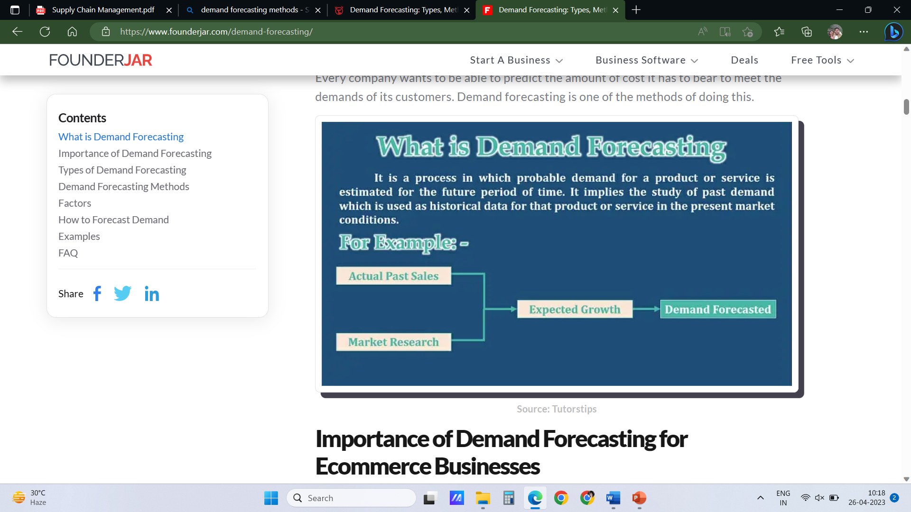

### 5 Demand Forecasting Methods

### Trend Projection

Trend projection uses your **past sales data to project your future sales**. It is the simplest and most straightforward demand forecasting method.

A time series representing the past sales and demand for a particular product is then formulated. These different graphical trends are followed closely and used to determine the expected future demand for products.

It’s important to adjust future projections to account for historical anomalies. For example, perhaps you had a **sudden spike in demand last year**. However, it happened after your product was featured on a popular television show, so it is unlikely to repeat. Or your eCommerce site got hacked, causing your sales to plunge. Be sure to note unusual factors in your historical data when you use the trend projection method.

### Conjoint Analysis

**The conjoint analysis involves the use of surveys to collect information about customer preferences as relating to a product.**

Surveys are typically in the form of **questionnaires** that seek preference information from customers. Consumers are asked about what they think of a particular product attribute and businesses make forecasts from their answers.

Information that surveys target to get from customers falls into personal, demographic, and economic information.

[**Conducting surveys**](https://www.founderjar.com/best-online-survey-software/)**helps a company to realize the most important selling point of their different products and services.** The reasons why consumers choose a certain product over others is identified and a company gets to know which product or service feature consumers value the most.

**Conjoint Analysis is a good demand forecasting method for products with no history.** When a company wants to **enter into another product category** or increases its inventory portfolio, information about the preferred attributes allows it to start on the right track.

Market preference and how consumers react to a product are collected and used accordingly.

### Delphi Technique

The Delphi method**involves the use of a group of experts that provide their individual forecasts and justifications for their forecasts.**

Each forecast and explanation is then read out to other experts on the panel, with each of them influenced by the forecast of their counterparts. A subsequent forecast is then made by each expert with the new influenced knowledge and this process repeats itself until a consensus is reached.

A consensus exists when there is no significant difference between the forecasts of the different experts.

**The Delphi method is based on the idea that an individual cannot accurately or effectively predict future demands all on his or her own.**When executed properly, the Delphi method is a very accurate technique of forecasting demands.

However, there are downsides to it. Apart from the need for highly knowledgeable experts on this panel to ensure accurate forecasts, **the Delphi method is time-consuming.**

### Intent Survey

**An intent survey aims to collect information about which product consumers are intending to buy in the future.** This technique aims at understanding the factors that push a consumer to buy a product.

Intent surveys are usually conducted through the websites of companies and typically ask website visitors to rate their **intent to buy a product on a scale of 0 – 10.**

Where intent is rated high, a company then decides on whether it should proceed to stock a product it was previously considering.

One point to note is that **intent surveys only predict the likelihood of a product being purchased and not the actual consumer behavior.**It is also better used to predict the purchase of existing products, durable products, and short-term forecasting periods.

### Econometric modeling:

Typically used for more advanced regressions. “Econometric modeling,” along with “econometric methods” and “econometric techniques,” are phrases that forecasters and business writers use to refer to a lot of different things. Econometrics is essentially how **economists use statistics to test hypotheses** and **model data,** and a lot of the techniques are forms of regression analysis. Many of the more advanced forms of regression-based forecasting fall under this heading, as do techniques used to test hypotheses about relationships between variables in data.The **econometric model** is a **quantitative method** identifying the relationships between economic trends. This technique pairs sales data with external economic forces to create a mathematical formula that predicts future customer demand.

**Supply Management**

**The term supply management refers to the act of identifying, acquiring, and managing resources and suppliers that are essential to the operations of an organization.** Also known as [procurement](https://www.investopedia.com/terms/p/procurement.asp), supply management includes the purchase of physical goods, information, services, and any other necessary resources that enable a company to continue operating and growing.

* Supply management is the act of **identifying, acquiring, and managing resources** and **suppliers** that are essential to the operations of an organization.
* It includes the purchase of **physical goods, information, services**, and any other necessary resources that enable a company to continue operating and growing.
* The main goals of supply management are cost control, the efficient allocation of resources, risk management, and the effective gathering of information for business decisions.

Oversight and management of suppliers and their contributions to a company's operations, for example, should be of paramount importance. Supply management personnel within a company or institution are generally responsible for the following:

* Identifying, sourcing, negotiating, and procuring a service or good that is essential to a company's ongoing operations according to the wishes of the organization's leaders and supervisors
* Formulating a strategy for **developing and maintaining relationships with suppliers**—and then executing on it—as well as **holding suppliers accountable**
* **Utilizing technology and procedures that facilitate the procurement process**
* Considering the theories of [supply and demand](https://www.investopedia.com/terms/l/law-of-supply-demand.asp) and what influence they have on supply management

## Concept of ERP in SCM

## 

**Enterprise resource planning, also known as ERP, is a system that helps automate and manage business processes across finance, manufacturing, retail, supply chain, human resources, and operations.**

ERP applications also allow the different departments to communicate and share information more easily with the rest of the company. It collects information about the activity and state of different divisions, making this information available to other parts, where it can be used productively.

ERP applications can help a corporation become more self-aware by **linking information about production, finance, distribution, and human resources together.** Because it connects different technologies used by each part of a business, an ERP application can eliminate costly duplicates and incompatible technology. The process often integrates accounts payable, stock control systems, order-monitoring systems, and customer databases into one system.

Eliminate Duplication

ERP systems tie together a multitude of business processes and enable the flow of data between them. By collecting an organization’s shared transactional data from multiple sources, ERP systems eliminate data duplication and provide data integrity with a single source of truth.

* ERP software can integrate all of the processes needed to run a company.
* Some benefits of ERP include the free flow of communication between business areas, a single source of information, and accurate, real-time data reporting.
* There are hundreds of ERP applications a company can choose from, and most can be customized.

## ERP examples across areas of business

### Finance

Increase profitability, **identify errors, eliminate duplication**, and ensure compliance with the business intelligence surfaced by well-defined ERP systems.

### Manufacturing

Accelerating **product delivery and production**, ERP systems bring a unified solution to manufacturing. **Tracking, scheduling, and optimising product manufacturing and delivery,** the benefits of ERP systems support the product to the customer and everything in between.

### Retail

Creating smooth and seamless operations, ERP systems provide a unified retail experience. Product information, stock, customer promotions, and sales data are all centrally managed, streamlining both in-store sales and online purchases.

### Supply chain

Drive optimisation, improve visibility, and streamline the supply chain—from sales to fulfilment. ERP systems help optimise logistics across production sites, warehouses, facilities, and transportation.

### Human resources

Providing centralised data on a single platform, human capital management systems are often integrated within ERP systems. Enable employee success through benefits administration, absence and leave management, options to attract and onboard top talent, and tools to ensure compliance.

## Benefits of Enterprise Resource Planning

### Improves Accuracy and Productivity

Integrating and automating business processes eliminates redundancies and improves accuracy and productivity. In addition, departments with interconnected processes can synchronize work to achieve faster and better outcomes.

### Improves Reporting

Some businesses benefit from enhanced real-time data reporting from a single source system. Accurate and complete reporting help companies adequately plan, budget, forecast, and communicate the state of operations to the organization and interested parties, such as shareholders.

### Increases Efficiency

ERPs allow businesses to quickly access needed information for clients, vendors, and business partners. This contributes to improved customer and employee satisfaction, quicker response rates, and increased accuracy rates. In addition, associated costs often decrease as the company operates more efficiently.

### Increases Collaboration

Departments are better able to collaborate and share knowledge; a newly synergized workforce can improve productivity and employee satisfaction as employees are better able to see how each functional group contributes to the mission and vision of the company. Also, menial and manual tasks are eliminated, allowing employees to allocate their time to more meaningful work.

## What Are the 5 Components of ERP?

The components of an ERP system depend on the organization's needs. However, there are key features that each ERP should include. Generally, packages include finance, human resource, logistics and manufacturing, supply chain management, and customer relationship management.

**Toyota Material Handling India switched from manually entering stock data into spreadsheets to using cloud-based ERP in its supply chain, which allowed the company to see a single view of stock across multiple locations and warehouses. As a result, employee productivity increased, turnaround time decreased, and resources were optimised.**

## The Role of ERP in Supply Chain Management

### 1. Demand & Planning

One important function of SCM is determining the quantity of materials, products, and resources required, including labor. An [ERP system with SCM capabilities](https://www.rootstock.com/cloud-erp/supply-chain-management-software/) creates **automatic** **supply and demand forecasts using historical and real-time data**, helping organizations quickly respond to constantly changing supply chains.

### 2. Sourcing Materials

Another important aspect of supply chain management is procuring materials and identifying the necessary suppliers, sub-contract manufacturers, and distributors. An ERP system with Material Requirements Planning (MRP) capabilities synchronizes demand with the materials required to produce products and houses all vendor information in one system for easy access.

### 3. Production

In supply chain management, managing the capacity you have across production lines and who you can **outsource/sub-contract** to for specialty functions or overflow is crucial. An ERP system helps organizations effectively [execute a production schedule](https://www.rootstock.com/cloud-erp/production-management-software/) by housing all production information, including requisitions, purchase orders, and materials replenishment.

### 4. Delivery

**Effective supply chain management involves maintaining relationships with shipping carriers who can provide predictable delivery to meet promised delivery dates.** An ERP system with Distribution Requirements Planning (DRP) capabilities tracks shipments, displays the quantity and number of items shipped, and links support and shipping to improve the speed and timeliness of delivery.

### 5. Finances

Another aspect of supply chain management involves financial management. [An ERP system with financial capabilities](https://www.rootstock.com/cloud-erp/accounting-financial-management-software/) helps organizations manage the credit limits negotiated with each of the nodes in the supply chain **and keeps payments up-to-date to avoid credit freezes**.

## Benefits

**Efficiently Fulfilling Order Demand:**Implementation of ERP automates order scheduling. It provides real-time information on the production status that helps allocate resources as and when required. Also, you can streamline and track the delivery process to prevent any bottleneck.

**Better Coordination Between Businesses & Vendors:**ERP in logistics and supply chain management keeps the business and the vendor connected in real-time. When your business receives the order, your supplier will be notified. This gives them the time to meet your logistics requirements on time. This ensures that there is no shortage of raw materials.

**Enhance Customer Satisfaction & Retention:**ERP for supply chain streamlines processes and operations in your warehouse. It enables your business to successfully run a smooth supply network, which ensures a timely order delivery every time. This builds trust amongst your customers and leads to repeat orders and retention.

### Optimized Inventory

An ERP system with inventory management capabilities helps organizations maintain sufficient inventory levels to avoid disruptive stockouts during peak demand while reducing the uncertainty that can lead to expensive excess inventory.

**Minimize Human Errors with Automation:**Automation means minimal human intervention in routine tasks. For instance, ERP for supply chain automatically requests for restocking the inventory when there is low stock. In this case, there is no scope for someone to raise the request manually, which eliminates the chance of any human errors.

# Evolution of ERP System

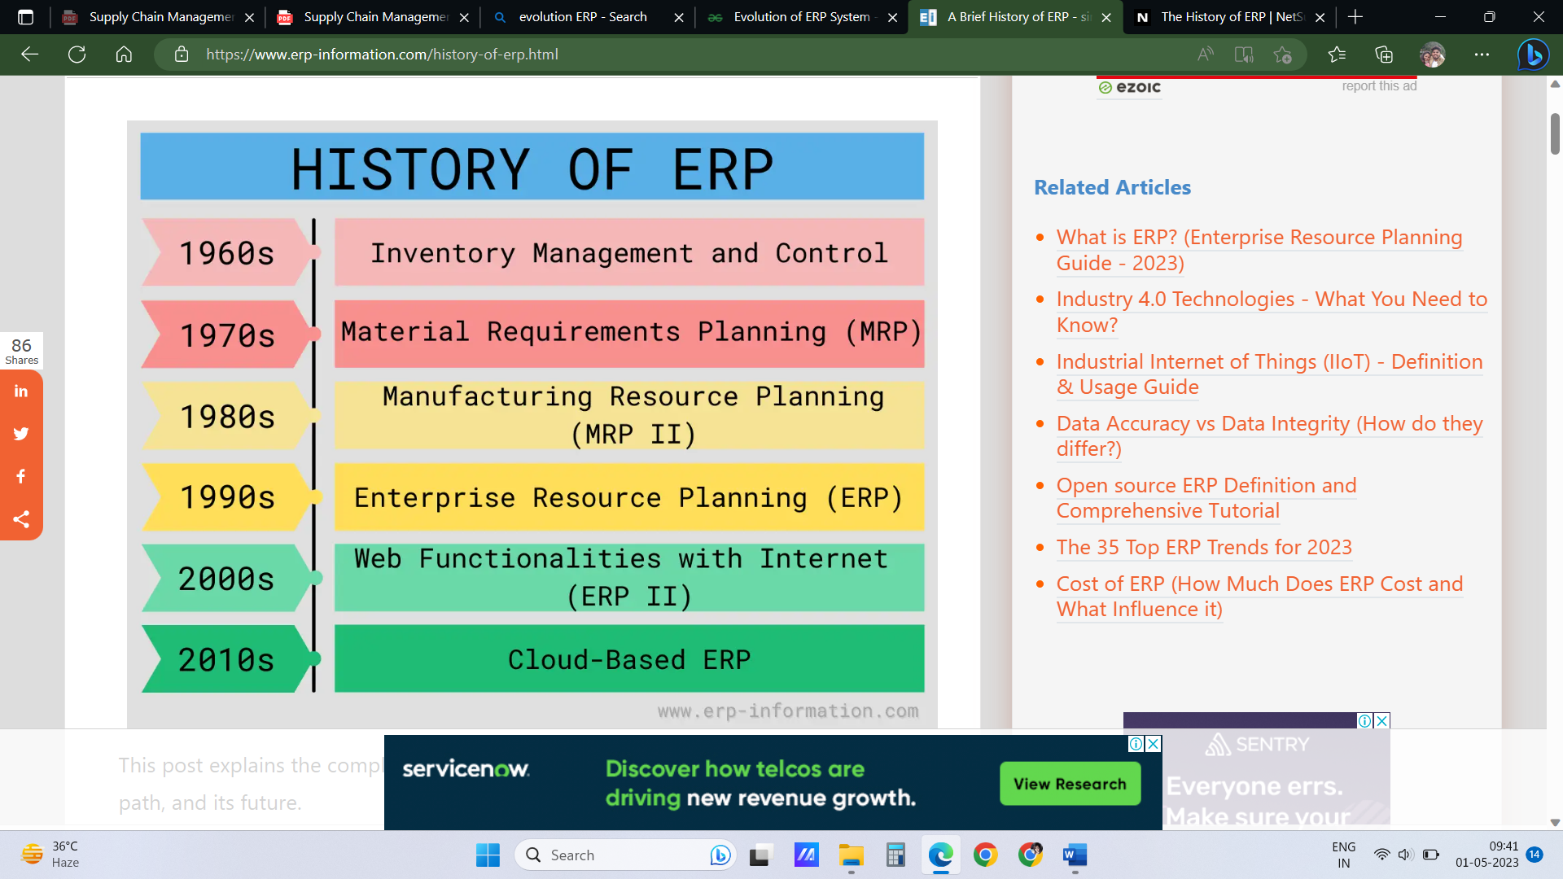

## Inventory Management & Control (the 1960s)

The history of ERP begins with [inventory management](https://www.erp-information.com/inventory-management) and control.

In the 1960s, manufacturing industries found that they required a system that should manage, monitor, and control their inventory.

[Inventory Management](https://www.erp-information.com/erp-inventory-module.html) and control combine information technology and business processes to maintain the appropriate stock level in a warehouse.

The activities of inventory management include,

* Identifying inventory requirements
* Setting targets
* Providing replenishment techniques and options
* Monitoring item usages
* Reconciling the inventory balances
* Reporting inventory status

## Material Requirements Planning (MRP)(the 1970s)

The next stage of the history of ERP is [material requirements planning](https://www.erp-information.com/material-requirements-planning-mrp).

The function of MRP is to provide material availability i.e, it is used to produce requirement quantities on time. This process involves monitoring of stocks and demand, leading to automatic creation of procurement proposals for purchasing or production. The main objective of MRP is to determine which material is required, quantity required and by when it is required.

Material requirements planning (MRP) utilizes software applications for scheduling production processes. MRP generates schedules for operations and raw material purchases.

## Manufacturing Resource Planning (MRP II) (the 1980s)

In the 1980s, vendors added more manufacturing processes to MRP to make the process easier and more accurate. And this new system is named manufacturing resource planning (MRP II).

[Manufacturing Resource Planning](https://www.erp-information.com/manufacturing-resource-planning.html)or MRP II utilizes software applications, Applications for coordinating manufacturing processes. Processes from product planning, parts purchasing, and inventory control to product distribution.

## Enterprise Resource Planning (ERP) (the 1990s)

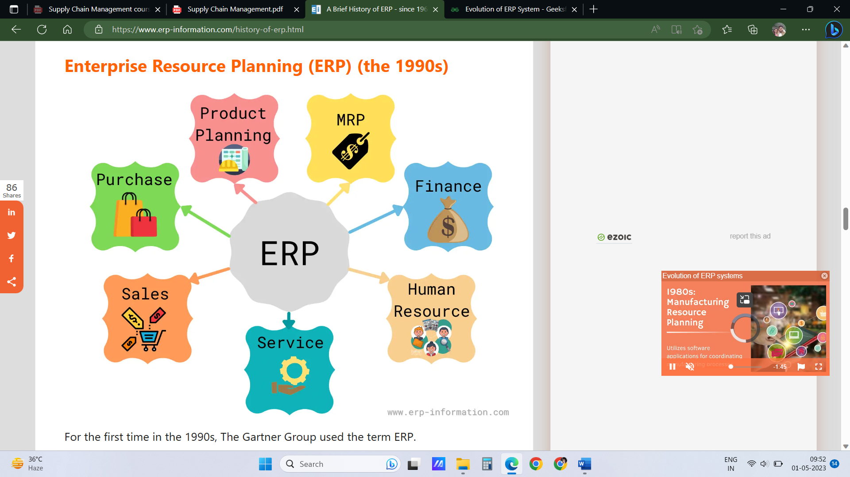

Enterprise resource planning or ERP uses a multi-module application software system. Software for improving the performance of the internal business processes.

ERP systems often integrate business activities across functional departments.

Departments including

* Product planning.
* Parts purchasing.
* Inventory control.
* Product distribution, fulfillment, to order tracking.

ERP software systems may include application [modules](https://www.erp-information.com/erp-modules.html) for supporting,

* Marketing.
* Finance.
* Accounting.
* [Human resources.](https://www.erp-information.com/erp-hr-module.html)

## Web Functionalities with Internet (ERP II) (the 2000s)

Technological advancement accessing information using internet web-browsers and mobile devices was made possible.

ERP II can enable access to information by those **outside the company** or **original entity**, e.g., a manufacturing plant that allows access to **planning information** by another plant or its customer.

These new business models reflect an increased business focus on internal integration. It’s domain is in all sectors and segments. Data in this is internally and externally published and subscribed.

It includes departmental modules, CRM, SCM and other stakeholders modules.

## Cloud-based ERP (the 2010s)

Business applications are delivered as a Software as a Service ([SaaS](https://en.wikipedia.org/wiki/Software_as_a_service)) model. Servers are deployed on the cloud and accessed with the rest APIs. Android, iOS, and browser applications are developed for delivering ERP software in the SaaS model.

It is helping businesses of all scales start using ERP systems since the upfront cost of cloud ERP systems is relatively minor.

Most of the prominent [top ERP vendors](https://www.erp-information.com/list-of-erp) are delivering services over the cloud.

**Quick Response and Accurate Response System in SCM**

Quick Response is a **retail sector strategy**, which combines a number of tactics to improve **inventory management** and **efficiency**, while **speeding inventory flows**. Most QRs are between **manufacturers** and **retailers** only. When fully implemented, **QR applies JIT** principles through the entire supply chain, from raw material suppliers through ultimate customer demand.

## Quick Response” was the term used by textile and apparel manufacturers and retailers to describe buyer-seller partnership relationship in which the buyer transmitted orders via EDI and the seller promised to fill orders quickly.

Customer’s sales are tracked immediately using EDI with bar code technology. It allows manufacturer to **notify raw material suppliers** and **schedule production** and **deliveries** as required to meet **replenishment needs**.

This allows **inventory reduction**, **speeding response** **times**, **lowering number of out of stock** **products**, reducing handling and obsolescence**.**

**QR was first implemented in Textile & Apparel industry**

EDI- Electronic data interchange. Electronic change of business information using a standardized format, rather than in paper format

QR aims to help organize a business in the face of problems associated with the vast array of goods and services now to be found in consumer markets. It is particularly relevant to the Fast Moving Consumer Goods (FMCG) and Fashion industries.

**Accurate Response System**

The “accurate response” system **distinguishes** those products for which **demand is relatively predictable** from those for which **demand is relatively unpredictable**, using blend of historical data and expert judgment

**Relatively predictable category**

The **relatively predictable category** should be made **furthest in advance** in order to reserve **more manufacturing capacity** for making **unpredictable products** closer to the selling season.

This enables companies to make smaller quantity in advance, see how well is the response for different items early in the selling period and then based on that information, decide which products to make more of.

**Relatively unpredictable category**

Unpredictable demand and short-lived products are the hallmarks of the world market for apparel. Demand for **fashion apparel**, being a function more of taste than of objective consumer needs, **long range forecasts tended to be highly inaccurate**.

Thus resulting shortages (stock outs) represent **lost sales opportunities**, surpluses represent lost revenues consequent to successive reductions (Markdowns), often to a point below the cost of production

Due to growing **demand uncertainty**, retailers discontinued the **practice of ordering large quantities of products in advance of the selling season and warehousing them until sold.** Instead they **ordered goods much closer to the selling season**, in small initial quantities that could be replenished as the season progressed. Retailers essentially looked at indirect costs such as those associated with high inventory levels and long lead times

This pushed the manufacturers to shorten order- fulfillment lead times and achieve higher order-fill rates. These trends drove the Quick Response movement.